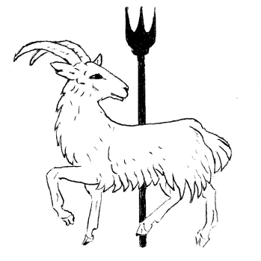

WORTHINGTON FAMILY HISTORY SOCIETY

# MEMBERSHIP APPLICATION

Full Name (please underline forename of use if not the first):

Address:

Telephone:

Email

:

Any honours, ranks, titles, degrees or other qualifications:

Brief account of career, especially as may be relevant to the work of the Society:

Any assistance you can provide the Society (e.g. research, genealogical, biographical, editing, typesetting, organising, etc):

Have you researched a Worthington family already? If so what geographic area has this covered and over what historic period?

Would you be willing to share this research with the Society in the future? Yes/No

Please read the Society’s Privacy Policy. If you are happy with the way the Society uses your data you do not need to do anything. You can read our Privacy Policy at www.worthingtonfhs.org/privacy-policy/

|  |
| --- |
|  |

Please tick the box if you wish your data to be withheld. Date: _____/_____/_______

*Data protection legislation demands that we ask for your permission to use personal details. In the case of the WFHS, this will be used solely to communicate with you (usually by way of email) and not for purposes of marketing or any form of advertising. To allow this please ensure the box is unticked. Thank you.*

**Membership Subscription Rates:**

The annual Worthington Family History Society subscription rate is GB£32 or US$42 or AU$55 or NZ$65, based on the year 1 April to 31 March. This amount is prorated based on the month of joining.

If you have any questions, please contact Hannah Murphy to whom completed Membership Application forms should be sent:

Hannah Murphy  
142, Bridge Street,  
Wye,  
Kent, TN25 5DP  
United Kingdom  
email: [wfhs.contact@gmail.com](mailto:wfhs.contact@gmail.com)

Subscription payments should be made in GB£ or US$ as follows:

For payments in GB£, cheques should be made payable to Worthington Family History Society and sent to Paul Lawrence, 1, Bayfield Place, Orpington, Kent, BR6 7FA, United Kingdom. An electronic payment can be made direct to the Society’s UK bank account, details of which can be obtained from Paul Lawrence [LPaulVLawrence@aol.com](mailto:LPaulVLawrence@aol.com).

For payments in US$, cheques should be made payable to Worthington Family History Society and sent to Lawrence Rickards, 2601 Woodley Place NW, Apt. 503, Washington, DC 20008, USA. An electronic payment can be made direct to the Society’s US bank account, details of which can be obtained from Lawrence Rickards [ldr1650@yahoo.com](mailto:ldr1650@yahoo.com).

Application payments from Australia and New Zealand should be made in GB£ equivalent as set out above.